**Exercise 2**

Brian Webb – ID: 34775506

Student

CSC120-10187: Digital Design Fundamentals

Dinesh Sthapit / Carlos Rodriguez

April 16, 2022

I do most of my installs via homebrew, luckily openlilberty has formulae for jakarta ee:

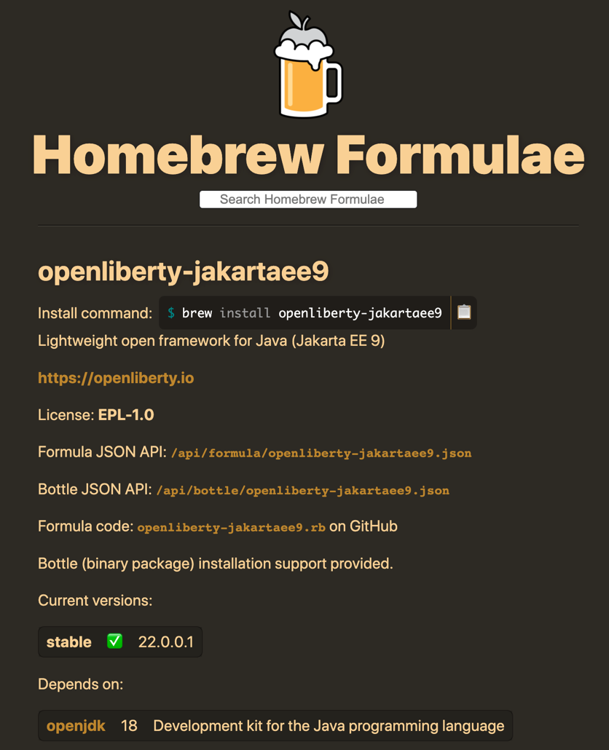

I got this installed but also had to update java:

